
Matthew Glanfield presents…
BBO Infinite Profits
A beginner’s fast-track to the infinite profits of the web…


All material contained in this e-book is Copyright © 2008 Glanfield Marketing Solutions Inc. and may not be reproduced, redistributed, or resold without prior written consent from this company.

Legal Disclaimer: While all efforts to provide correct information have been made, we cannot guarantee any success or any sort of income from reading this e-book. We do have confidence that if you read and study this e-book, and APPLY what is taught, that you can see great wealth through your own Internet business. However, we cannot legally guarantee anything. We are not responsible for the loss of income, time, or any damages that applying what is taught in this e-book may cause (although we don’t think that any of that will happen!).

This is a FREE Preview

This is NOT the full e-book.

If you would like to download the rest of this e-book,
simply go to the following link:

http://www.bboinfiniteprofits.com/full.php

If you would like to give away this free chapter to your list and make commissions off of sales of the full e-book, then register here as an affiliate:

http://www.mattsaffiliates.com

Preface - or “Why I created this e-book”

I know what you’re thinking right now. You’re thinking, “I don’t really care why you created this e-book, I just want to make money online!”

And hey, I agree with you! I hate buying e-books where they spend the first 50 pages telling you how great they are and how much money they have made and how great the Internet is and why you should consider getting into it and all that other boring stuff…

Sigh… Why not just teach the stuff that makes money?

That is why I created this e-book, and that is why you should stop everything else you are doing right now, and read through EVERYTHING here as quickly as you can.

Sure, you could just read the first few chapters and then go and apply it (you ARE going to apply this, aren’t you?), but then you’d be missing out on the bigger picture.

That’s right, the bigger picture.

What is this bigger picture? Well, I can tell you what it isn’t.

It isn’t:

- How to make money by selling e-books
- How to make money by selling other people’s products (i.e. affiliate marketing)
- How to get more traffic
- How to make more sales
- How to build a list

All of those things are great, and they do help you to fulfill your dreams, but they aren’t what make a business a profitable business.

Chapter 1 – The Infinite Profits System

So what makes a profitable business?

Ah, that is the right question. And to answer that in its fullest you will need to read this entire e-book.

Don’t worry. I won’t fill this up with a ton of fluff that will take up 150 pages to teach what could be taught in 10.

I’ll cut through the B.S. and the false ideas that are out there, and I’ll show you where the REAL money is.

And no, it’s not in e-books.

And no, it’s not truly “in the list.”

And no, it’s not in affiliate marketing.

So what is the “big secret” of the “bigger picture?” It’s quite simple actually. In fact, I can sum it up into one word.

Ready?

Here it is:
Continuity.

You should highlight that right now. Oh, you don’t have a highlighter? Ok, I’ll do it for you:

Continuity.

Yup, that’s the big secret. And most people still haven’t figured it out. Most people are too busy selling their $67 e-books to as many people as will buy them, trying to cash in on the $30 profit margin that they get when an affiliate sells their product.

How many e-books would you have to sell to make $100,000 per year if you made $30 per e-book (after affiliate commissions, PayPal fees, etc.)?

Let’s do the math:

$100,000 / $30 = 3333.3333…, or about 3334 e-books per year, or a little over 9 per day.

Let’s say you get a 1% conversion rate (we’ll talk about what this means later, but let’s just say that it means for every 100 people that visit your site, one purchases). That would mean you would need over 900 visitors per day ON AVERAGE for the entire year.

Sound like a lot? It is, unless of course you have a ton of huge partners ready to send out promotions for you.

You don’t? Well, then you may want to listen to what I have to say. ;)

All kidding aside, there is a much easier and better way to make $100,000 in a year, and most people will be able to do it within their first year.

Oh wait, I just got a phone call from my lawyer. Hold on a second…

Matthew: “Yes?”

Lawyer: “You can’t tell people that most people can make a certain income in their first year!”

Matthew: “Why not?”

Lawyer: “Because then you’ll get sued when they don’t succeed!”

Matthew: “Sigh… Alright, I’ll tell them what I really mean…”

Ok, I’m back. My wonderful lawyer wanted me to tell you that I can’t guarantee any income.

Well, I didn’t. However, allow me to clarify:
If you apply what I will teach you in this e-book, you have the POTENTIAL of making $100,000+ in your first year.

Clear enough?

And just a side note, the one big thing that keeps people from this potential is a simple lack of focus and a lack of action-taking.

If you want to be like 99% of the failing “business owners” out there, simply do nothing and you’ll “succeed” just like they have.

Wait a second! I never finished telling you all about continuity and why it is included in the Infinite Profits system!

Well, you’ll find out in this chapter, I promise. And for those of you who don’t even know what the word “continuity” means, you’ll be an expert on it by the end of this book.

So what exactly is the Infinite Profits System? Well, it can be broken down into 6 simple steps:

The Infinite Profits System
1. Find a niche.
2. Create a front-end product.
3. Make sales.
4. Create a serious back-end continuity product.
5. Link front-end to back-end.
6. Create more front-end products.

Don’t worry, if you aren’t familiar with terms such as “niche”, “front-end”, “back-end”, or “continuity”, it will all be explained to you here.

Now, before we go any further I realize that you may have seen certain elements in this system before. Obviously finding a niche (AKA “knowing what you are going to sell”) is essential to any business.

However, what really makes this system stand out and work so incredibly well is steps 4 through 6.

Allow me to explain – remember how we were talking about how hard it would be to make $100,000 just selling e-books? Well it’s true!

When I first started teaching people how to make money through affiliate marketing (that was the second online business I started), I started with a $97 e-book (the price changed around, but it was around $50 - $100 at any given time).
I was able to make quite a bit of money, but it wasn’t until I created YourSqueezePage.com, which is a continuity product, that my revenue sky-rocketed. I ended that year (the FIRST year of that particular business) with around $300,000 in revenue.

I could not have done it without the continuity part.

That allowed me to harness the power of residual income, and also the power of back-end products.

Ok Matthew, what is a “Continuity Product?”
I keep using the phrase, so I’d better explain it.
A continuity product is a product that people pay a subscription fee to access. Typically this is a monthly membership site, where people pay $10 - $500 per month in order to gain access to training, software, or any other benefits.
The reason this is so effective and profitable is because you aren’t just getting one-off sales, you are making residual (recurring) income.
Let’s do a quick calculation. If you were able to add only 50 members per month (that isn’t much) to a $20 per month continuity program, you would be making how much in only 6 months?
50 members x 6 months x $20 per month = $6,000 per month!
What about after a year?
50 members x 12 months x $20 per month = $12,000 per month!
The key here is that once you get a new member, they continue to pay month after month (provided you do things right).
Alright, let’s get back to what we were talking about.

We’ll talk more about continuity products in a later chapter.

Hopefully by this point you aren’t too overwhelmed. If you are, don’t worry, just take this one step at a time. While the system may look difficult it really isn’t, mainly because it focuses on building your business, not just creating it.
Chapter 2 – Who on earth are you gonna sell to?

A HUGE word of warning – do NOT spend all of your time on this step, or you’ll NEVER make any money.

Choosing your “niche” is probably the most important part of your business, and yet I still think that people spend too much time on it. When I decide to start a new business in a new niche, I spend about 30 minutes to an hour researching and choosing a niche.

That’s it. One hour at most.

That’s all I really need. The Internet is one of the easiest places to do two things:

- Competitive analysis – learn all about people ALREADY making money
- Economic analysis – learn all about what people are ALREADY buying

You are not going to try to discover a “new market” that nobody else is selling to. You don’t want to invent a new type of product that nobody has ever heard of before but that everybody will need.

Your goal is simple:

GO WHERE PEOPLE ARE BUYING AND SELL TO THEM!

If I had a motto I think that would be it. Let me spell this out in another way:

- Find out what people are looking for.
- Find out if the profit margins are good.
- Check out how much competition there is.
- If the profit margins are good, and there is a lot of competition, you’ve found a great niche.

That’s all there is to it. The step that is probably the hardest is #1, not because you don’t have the tools, but because it is so broad.

The way I see it, there are two main types of products that you can sell on the Internet. They are:

- Information products (i.e. info-products)
- Physical products (i.e. e-commerce)

There are combinations of the two, but for all intents and purposes I am going to keep those two categories separate.

This e-book is going to focus on the first category, so all of the advice that I am about to give you is about how to find a great niche market for an info-product business. I use a slightly different approach for finding what people are looking for when I start an e-commerce store.

The reason for this is that the mind set of consumers who are buying info-products is much different than those who are shopping for normal physical products (think about the last time you were in a department store as opposed to the last time you were on an info-product sales page).

While information products are some of the easiest to create, and have the highest profit margin, I am going to suggest that you stick to markets that fall under one or more of the following qualifications:

3 Types of High-Potential Info-Product Niche Markets
- How to make money.
- How to save money.
- How to improve your lifestyle.

While you can definitely succeed in markets that don’t fall under these three types, it will be much easier if you play to these needs.

Now, do NOT think that I am encouraging everybody to start teaching Internet Marketing (i.e. How to make money through creating an Internet business). If that is what you really want to do, go for it! But don’t choose that market simply because you think it is the only place where you can make a lot of money.

I’ll give you a few examples of each category. Some examples may fall under more than one category.
1. Examples of Markets in the “How to make money” Area
- Internet Marketing and its many branches
- Real Estate
- How to start your own [FILL IN THE BLANK] business
- Foreign Exchange
- Investing

2. Examples of Markets in the “How to save money” Area
- How to pay less taxes
- “Do-it-yourself” markets (e.g. home improvement, car repair)
- How to pay less for gas
- How to find [FILL IN PRODUCT TYPE] cheap

3. Examples of Markets in the “How to Improve your Lifestyle” Area
- Weight Loss
- Eating Healthier
- Quitting Smoking
- Overcoming Addictions
- Overcoming Disorders (e.g. ADHD)
- Family Improvements

There are MANY more examples that I could give, but I think this gives you a good idea of what we are looking at.

Basically the idea behind choosing a market within these three categories is that we are playing to the basic human emotional needs. Beyond basic survival, everybody wants to live better lifestyles, and that is perceived to come through having more money (or saving money) or through better health or better relationships.

Remember, people purchase based on emotion and justify their purchase based on logic, so if you can’t appeal to the emotional side of your customers, you are going to have a VERY hard time making any sales.

Some places to get ideas…

If you are stuck with ideas of areas that could help, here are a few places that I often go to get ideas of what types of information people are looking for.

1. ClickBank (www.clickbank.com)

Visit ClickBank’s marketplace to see the categories that they have set up. They list over 10,000 information products, so you can bet that the categories listed there will be lucrative ones.

2. Alexa’s Web Directory (www.alexa.com)

Looking at any web directory will give you plenty of ideas to start with. I like Alexa’s directory because it tells you how many sites it has listed right beside each directory.

Look for sub-categories with large amounts of websites and you’ll know you have found something that people are looking for.

3. DON’T Use eBay (www.ebay.com)

One place I suggest that you don’t use is eBay.

Now, why would I include a site that I wouldn’t suggest using? It is simply because I would use eBay if I were starting an eCommerce store, because they focus more on physical products.

99% of the information products that are being sold on eBay are about how to make money with Internet Marketing and by selling on eBay, so you won’t get a wide variety of ideas from this site.

Start with the idea, and then apply the litmus test…

When I was in high school chemistry class (*shudder*) I learned about something called a “litmus test.” Basically if you had a liquid that you were trying to determine the acidity of, you could dip a piece of litmus paper into it.

The litmus paper would instantly change color, after which you compared it to a chart to determine how acidic the liquid was.

The beauty of the “litmus test” is that it is nearly instantaneous.

Well, the Internet provides many resources so that we can create litmus tests of our own for niche market ideas.

Now, while the tests I am about to show you aren’t instant, they are pretty close! If you give me an idea I can tell you within 5 minutes if it has a high potential for success or failure.

Do you like the sound of that? I sure hope so.

No more “guessing” whether something will work.

No more “trying something out” to see if it will work.

No more hanging on to an idea just because YOU think it’s a good one!

You have to be prepared to scrap what appear to be good ideas when they fail these litmus tests miserably. Failure to do so will result in, well, failure!

(Slight disclaimer: These litmus tests aren’t 100% accurate, but they are WAY better than our own opinions on what works.)
Litmus Test #1 – Are People Searching For It?
- Go here:
https://adwords.google.com/select/KeywordToolExternal
- Type in one to three keyword phrases that best describe your market (e.g. weight loss, lose weight).
- If there are a lot of related keywords with a decent amount of search volume, it passes!
If there are a lot of related keywords with a TON of search volume, you probably want to narrow your topic.
Otherwise, it fails…

I’ll give you an example of a pass and a fail (with screenshots to help you out).

Good Example #1 – dog training (fits in “Lifestyle Improvement” category)

I typed in dog training in the keyword tool and got this (see next page):

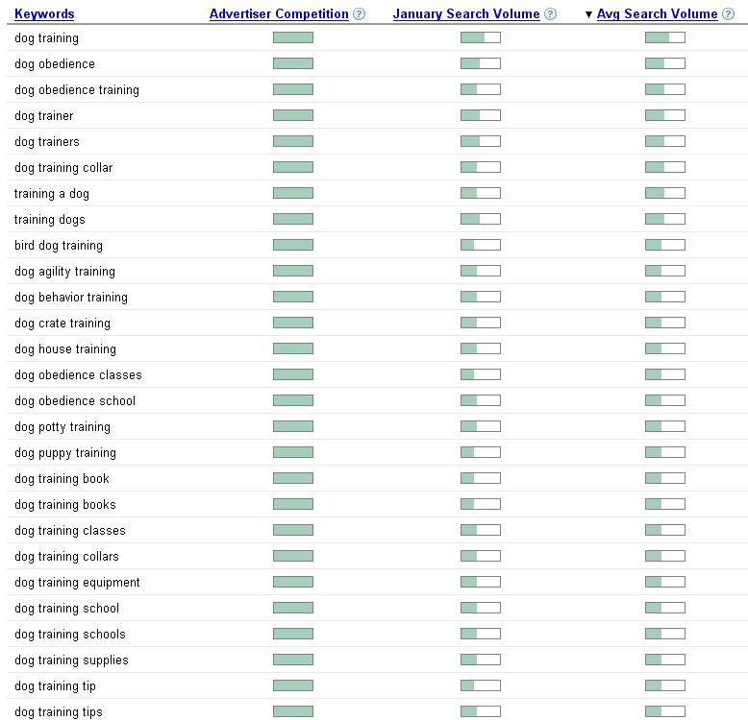

Now, what we are looking at here is “Avg Search Volume” and not anything else.

As you can see there are a lot of related keywords (the list goes on beyond the screenshot above) that receive a decent amount of traffic (i.e. around half a bar).

That means that “dog training” passes the first litmus test.
Bad Example #1 – real estate (fits under “Make Money” category)

This is what I got when I typed in the term “real estate.”

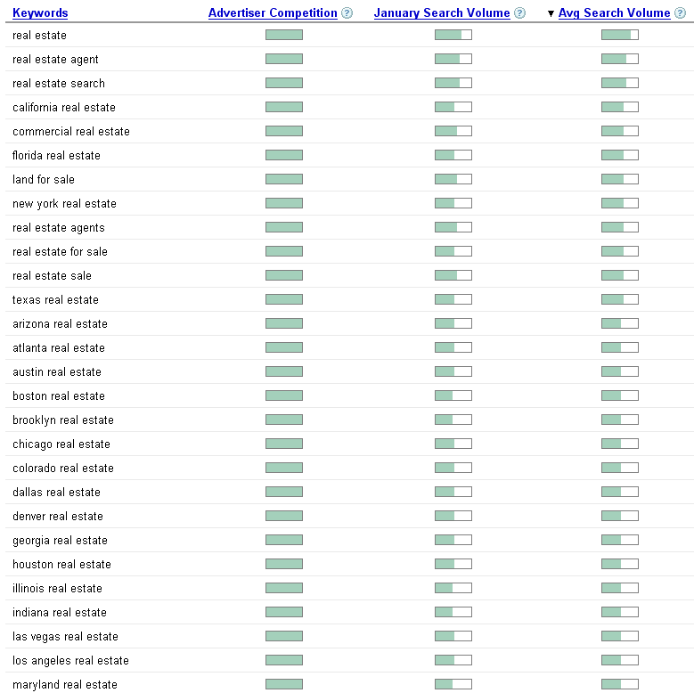

As you can see the keywords aren’t really that related to somebody looking for an info-product.

Wait a second! You said real estate was a good market!

And it is. However, that doesn’t mean that you are going to go and make a website about “real estate.” What I said was a good market is teaching people how to make money from real estate, not on how to get an agent or on properties in certain areas.
Litmus Test #2 – Are There Good Profit Margins?
- Go to www.google.com and type in a couple of your main keywords.
- If there are a lot of sponsored ads, then there are good profits to be made.
If not, then this test fails.

It’s one thing to have a lot of “searchers” in a market, but what you really want are buyers.

Unfortunately it’s not always easy to know how many of those searchers are buyers, so we are going to do a bit of a reverse economic review here.

To do this I need to explain a small portion of what I learned in first year University Economics. This has to do with supply and demand.

You have probably heard of this before. Where there is a group of people looking to spend money on a certain product or service (i.e. demand) there will always be businesses to sell those products or services (i.e. supply).

Every market always finds some sort of equilibrium, where new companies are entering and old ones are failing, and the good ones are sticking around to serve more and more customers.

What we want to find is a market with a high amount of demand. So how do we determine that? We look for a high amount of supply.

Remember, where there is a lot of demand (i.e. customers), there will be a lot of supply (i.e. vendors).

But how do we tell if a market has a lot of supply? Do we simply look at the number of websites that show up for a particular search? Of course not! All that tells us is the number of pages that Google knows of that mention your keywords in them, not suppliers!

Instead we look at advertisers. If there are a lot of advertisers (i.e. companies paying for advertising) in a market, then there MUST be profits! Otherwise the companies would soon lose money and stop advertising.
Of course there are always new companies in markets who start advertising before making any profits (that’s how you have to start!), so there will almost always be some sort of advertisers in any market.

That’s why we look for markets with LOTS of advertisers, because it proves that there must be high profit margins!

So here is what you do:

- Go to www.google.com.
- Type in your keyword phrases.
- See how many sponsored ads there are for that phrase.

Take a look at this screenshot for the search phrase “recipes”:

(on the next page)
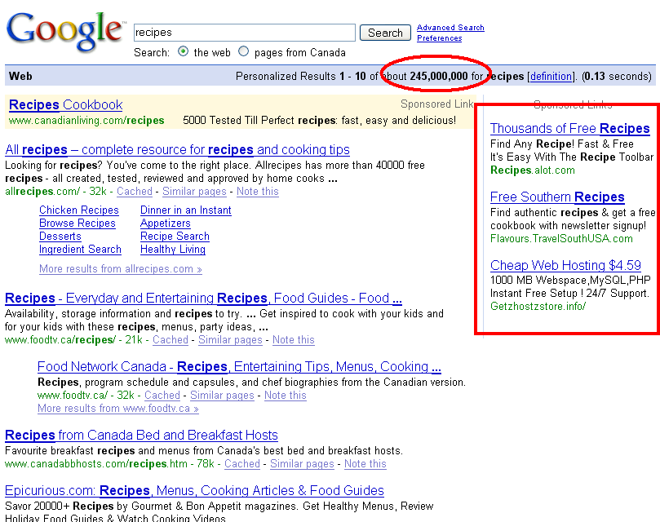

I put a red box around the sponsored ads, and a red circle around the number of “natural” listings (i.e. web pages that show up for free because Google thinks they should).

As you can see there are TONS of websites that mention recipes (at least 245 million!). However, there are only three advertisers that we can see, and one of them doesn’t even sell recipes!

This tells us that while there are plenty of searches for recipes, the profit margins are really low.

Let’s look at another keyword, “quit smoking”:

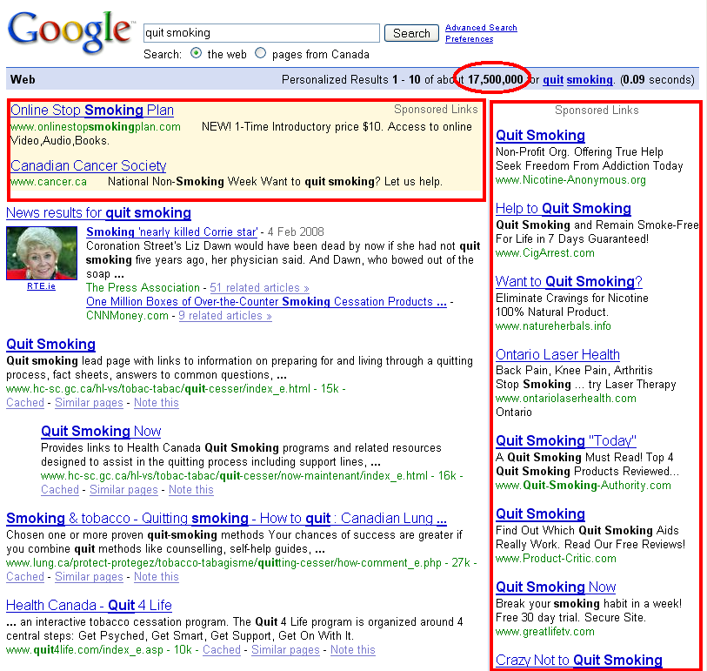

As you can see there are a LOT of advertisers that want to teach you how to quit smoking (there are even more that aren’t shown on the screenshot above).

That tells me that there must be good profit margins in selling products related to quitting smoking.

Now, you may ask me exactly how many advertisers you should see before determining that your market passes the test, and I’ll tell you that there is no “magic” number.

However, since most people aren’t happy until they hear a number, I’ll say 10.

There you have it. If there are 10 or more advertisers, then it passes litmus test #2!
Litmus Test #3 – Is There Competition?
- Type in your main keyword phrases.
- Visit the top results in Google.
- Visit the sponsored ads in Google.
- Are the majority of these sites considered competition?

Just a small warning: this is going to be VERY counter-intuitive. Just trust me on this.

You absolutely want there to be good competition!
What I mean by “good competition” is:

- They know how to build a list (i.e. they are using squeeze pages and opt-in forms).
- They know how to write a good sales letter.
- They offer good products.
- They offer info-products.
- (optionally) They are search-engine savvy.

Now, why would you want good competition? If I were starting an e-commerce store I would actually do the exact opposite and look for markets where the competition is not very savvy.

However, in the info-product realm of the Internet, there is one underlying factor that can accelerate you to wealth in a tremendously short period of time…

PARTNERS!

The way I see it there is no such thing as competition! They are all potential partners!

As you will discover later on in this e-book, one of the best ways to build your business is through partners and affiliates (i.e. other people who sell your product for a commission). It is how I have built hundreds of thousands of dollars of revenue, and it is how you will do the same.
Sure, there are all sorts of other methods to drive traffic, and I do suggest that you use them. But the one that can make the biggest difference the fastest is partners.

So, if you enter a market with no marketing-savvy competition, then you are going to find it hard to form solid partnerships that will move you forward the fastest.

If the market passes these 3 litmus tests, then you have a winner!

Let’s go over these tests one more time:
Litmus Test #1 – Are People Searching For It?
- Go here:
https://adwords.google.com/select/KeywordToolExternal
- Type in one to three keyword phrases that best describe your market (e.g. weight loss, lose weight).
- If there are a lot of related keywords with a decent amount of search volume, it passes!
If there are a lot of related keywords with a TON of search volume, you probably want to narrow your topic.
Otherwise, it fails…

Litmus Test #2 – Are There Good Profit Margins?
- Go to www.google.com and type in a couple of your main keywords.
- If there are a lot of sponsored ads, then there are good profits to be made.
If not, then this test fails.

Litmus Test #3 – Is There Competition?
- Type in your main keyword phrases.
- Visit the top results in Google.
- Visit the sponsored ads in Google.
- Are the majority of these sites considered competition?

If not, then this test fails.

Clear enough? Then go find your market and move on quickly!

Honestly, you should not spend more than a few hours on this, mainly because it will hold you up from actually making money.

Speaking of making money, let’s talk about making your first product.

There is even more…
Thank you for reading this free preview of my e-book BBO Infinite Profits.
If you would like to get the rest of this e-book, simply go here:
http://www.bboinfiniteprofits.com/full.php

